Metal Inert Gas Welding (MIG) OR GMAW
This process is also termed as gas metal arc welding (GMAW).
17.1 Fundamentals of MIG welding
This process is based on the principle of developing weld by melting faying surfaces of the base metal using heat produced by a welding arc established between base metal and a consumable electrode. Welding arc and weld pool are well protected by a jet of shielding inactive gas coming out of the nozzle and forming a shroud around the arc and weld.

MIG vs TIG WELDING
MIG weld is not considered as clean as TIG weld. Difference in cleanliness of the weld produced by MIG and TIG welding is primarily attributed to the variation in effectiveness of shielding gas to protect the weld pool in case of above two processes. Effectiveness of shielding in two processes is mainly determined by two characteristics of the welding arc namely stability of the welding arc and length of arc besides other welding related parameters such as type of shielding gas, flow rate of shielding gas, distance between nozzle and work-price. The MIG arc is relatively longer and less stable than TIG arc. Difference in stability of two welding arcs is primarily due to the fact that in MIG arc is established between base metal and consumable electrode (which is consumed continuously during welding) while TIG welding arc is established between base metal and non-consumable tungsten electrode. Consumption of the electrode during welding slightly decreases the stability of the arc. Therefore, shielding of the weld pool in MIGW is not as effective as in TIGW. Metal inert gas process is similar to TIG welding except that it uses the automatically fed consumable electrode therefore it offers high deposition rate and so it suits for good quality weld joints required for industrial fabrication (Fig. 17.1). Consumable electrode is fed automatically while torch is controlled either manual or automatically. Therefore, this process is found more suitable for welding of comparatively thicker plates of reactive metals (Al, Mg, Stainless steel). The quality of weld joints of these metals otherwise is adversely affected by atmospheric gases at high temperature.
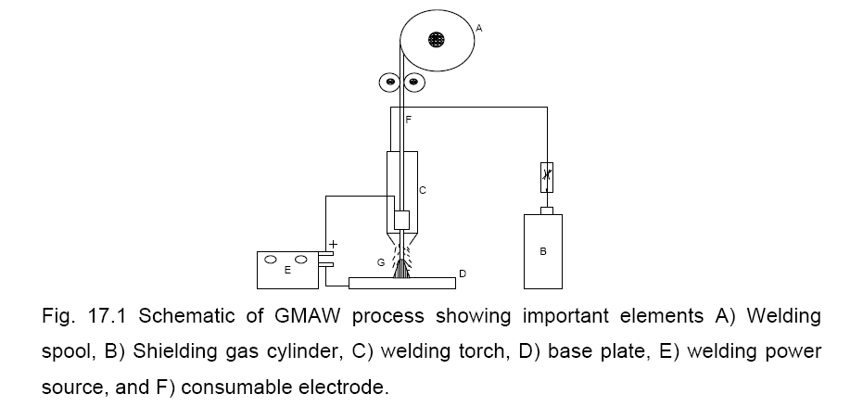
17.2 Power source for MIG welding
Depending upon the electrode diameter, material and electrode extension required,
MIG welding may use either constant voltage or constant current type of the welding
power source. For small diameter electrodes (< 2.4 mm) when electrical resistive
heating controls the melting rate predominantly, constant voltage power source
(DCEP) is used to take advantage of the self regulating arc whereas in case of large
diameter electrode constant current power source is used with variable speed
electrode feed drive system to maintain the arc length
17.3 Shielding gases for MIG welding
Like TIG welding, shielding gases such as Ar, He, CO2 and their mixtures are used for protecting the welding pool from the atmospheric gases. Effect of the shielding gases on MIG weld joints is similar to that of TIG welding. Inert gases are normally used with reactive metal like Al, Mg and while carbon dioxide can be used for welding of steel for reasonably good quality of weld joints. MIG welding with Ar as shielding gas results in significant change in the mode of metal transfer from globular to spray and rotary transfer with maximum spatter while He mainly produces globular mode of metal transfer. MIG welding with CO2 results in welding with a lot of spattering. Shielding gas also affects width of weld bead and depth of penetration owing to difference in heat generation during welding.
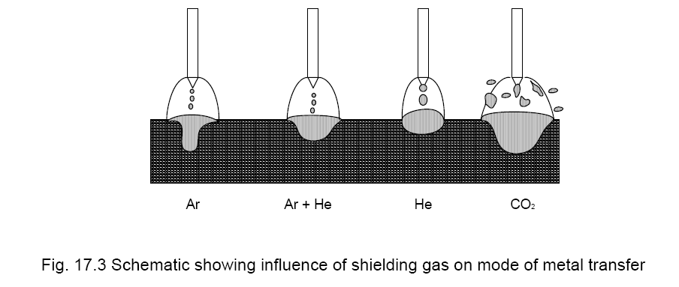
17.5 Metal transfer in MIG welding
Metal transfer during MIG welding depending up on the welding current, electrode diameter and shielding gas can take place through different modes such as short circuit, globular, spray Increase in welding current changes mode of metal transfer from short circuiting to globular to spray transfer specially when Ar is used as a shielding gas
17.7 Flux cored arc welding process
The flux cored arc welding (FCAW) is another variant of gas metal arc welding process. Like GMAW, this process mainly uses constant voltage power supply. The FCAW uses a tubular electrode filled with flux and other constituents that decompose at high temperature in arc environment to produce inactive gases to protect the weld pool and arc zone from contamination by atmospheric gases. The role of flux in FCAW process is also similar to shielded metal arc welding, however unique feature of filling of flux in continuously fed tubular electrode associated with this process for welding gives freedom from regular stoppage of welding for replacement of electrode. This in turn results in high welding speed and productivity. Since protective gases are generated in the arc environment itself therefore ambient air flow/turbulence doesn’t affect the protection of the weld pool appreciably.
This process also used in two ways a) FCAW without shielding gas and b) FCAW with external shielding gas arrange like GMAW. The FCAW process with shielding gas results in somewhat more sound weld with better mechanical properties than FCAW without shielding gas owing to the possibility of formation of few weld discontinuities in weld metal like porosity, slag inclusion etc. in later case. FCAW without shielding gas suffers from a) poor slag detachability, b) porosity formation tendency, c) greater operator-skill requirement and d) emission of harmful noxious gases and smokes imposes need of effective ventilation. Further, excessive smoke generation in case of FCAW without shielding gas can reduce visibility of weld pool during welding which can make the process control difficult. FCAW with external shielding gas provide much better protection to the welding pool and arc zone. FCAW is commonly used for welding of mild steel, structural steel, stainless steel and nickel alloys.

